
Quantum Cryptography:
Principles of Quantum Physics
Applied to Information Processing

Objective of this module is to introduce students to the fundamental principles of quantum cryptography and demonstrate how quantum physics concepts can be applied to ensure secure information processing, data transmission and communication. Students will acquire the necessary quantum foundations and understand how quantum phenomena such as superposition, measurement, and entanglement provide new approaches to cryptographic security. At the end of this module, students will be able to describe and analyze a quantum cryptographic protocols (for example BB84), explaining its operation and security principles.

Activity with the interface:
https://qtechedu.centralesupelec.fr/EN/ex10.html

1. Introduction: From Classical to Quantum Cryptography
- What is cryptography? Define its objectives, methods, and main applications. Briefly describe the historical stages of its development.
- What are the main principles of cryptography?
- What are the most important modern applications of cryptography?
- What were the main characteristics of classical cryptography, and how did methods such as the Caesar cipher and the Vigenère cipher provide security?
- What is Kerckhoffs’s Principle, and why is it considered a fundamental concept in modern cryptography?
- How does modern cryptography differ from classical cryptography in terms of security assumptions and algorithm design?
- What are the two primary objectives of modern cryptographic research, and how are they related to secure communication?
- What is symmetric cryptography? Give examples of symmetric cryptographic protocols or algorithms. What are its advantages and limitations?
- Describe the AES-128 encryption algorithm and explain its main operating principles.
- What is the One-Time Pad (OTP)? Why is it considered theoretically unbreakable?
- What is asymmetric (public-key) cryptography? How does it differ from symmetric cryptography? Give examples of asymmetric cryptographic algorithms.
- Explain the principles of the RSA cryptosystem.
- Estimate the vulnerability of the Caesar cipher to brute-force attacks. Why is it considered insecure today?
- What limitations of classical and modern cryptographic systems motivated the development of quantum cryptography?
- What is quantum cryptography, and what are its main advantages compared with classical cryptography?
- Why is secure key distribution considered one of the most important challenges in cryptography? How could advances in computing power, particularly quantum computing, threaten traditional cryptographic systems?
- What are the main types of cryptographic attacks? Briefly describe attacks such as brute-force attacks, man-in-the-middle attacks, known-plaintext attacks, chosen-plaintext attacks, and side-channel attacks.
2. Foundations of Quantum Information and Computing
1) Qubit and Superposition:
- List the main properties of a qubit. Give a definition for each of them.
- What is a qubit, and how does it differ from a classical bit? Explain the principle of superposition for a single qubit.
- How is a general quantum state mathematically represented? What condition must the probability amplitudes satisfy?
- How does the principle of superposition extend from a single-qubit system to a multi-qubit system?
- What is the tensor product, and how is it used to construct multi-qubit states? Express the state ∣q₁q₂⋯qn⟩ using tensor-product notation.
- For an nnn-qubit system, how many computational basis states exist, and why? List all computational basis states of a two-qubit system.
- Write the most general state of a two-qubit system. How can a two-qubit state be represented in column-vector form? Give the vector representation of the basis state ∣10⟩|10\rangle∣10⟩.
- Convert the following quantum states between Dirac notation and vector notation:
- ∣0⟩
- ∣1⟩
- (1/√2)(∣0⟩ + ∣1⟩)
- ∣01⟩
- ∣10⟩
- Verify that each state is properly normalized.
- Given a two-qubit state in vector form, identify the corresponding Dirac notation and determine the amplitudes associated with each computational basis state.
- What information is represented by the individual qubits in the state ∣01⟩?
- How is the principle of superposition related to the postulates of quantum mechanics?
- What is the principle of superposition, and which postulate(s) of quantum mechanics does it follow from?
2) Quantum Gates:
- What are quantum gates? How are quantum gates similar to classical logic gates?
- What role do quantum gates play in quantum computing?
- What condition must a quantum gate satisfy? Why must quantum gates be unitary?
- Which postulate of quantum mechanics describes the evolution of quantum gates?
- What are the properties of the Identity gate?
- What do the Pauli-X, Pauli-Y, and Pauli-Z gates do?

Quantum Gates and Quantum State Manipulation
- What is a quantum gate? How does a quantum gate differ from a classical logic gate?
- What are the computational basis and the diagonal basis? Write the basis states for each basis.
- Express the diagonal basis states ∣+⟩ and ∣−⟩ in terms of the computational basis states ∣0⟩ and ∣1⟩.
- What is the matrix representation of the Pauli-X, Pauli-Z, and Hadamard (H) gates? Describe their action on a single qubit.
- Apply the following quantum gates and determine the resulting state:
  - X∣0⟩
  - X∣1⟩
  - H∣0⟩
  - H∣1⟩
  - Z∣+⟩
- Convert the resulting states from Question l between Dirac notation and vector notation.
- What is the effect of applying the Hadamard gate twice to a qubit? Verify your answer mathematically.
- What is the Controlled-NOT (CNOT) gate? Give its matrix representation and explain the roles of the control and target qubits.
- Determine the output of the CNOT gate for the following input states:
  - ∣00⟩
  - ∣01⟩
  - ∣10⟩
  - ∣11⟩
- Starting from the state ∣00⟩, apply a Hadamard gate to the first qubit and then a CNOT gate. Write the final state and explain why it is an entangled state.
- Given a quantum state in the computational basis, determine its representation in the diagonal basis, and vice versa.
3) Measurement:
- What is the role of measurement in quantum mechanics, and how does it differ from measurement in classical physics?
- Which postulate of quantum mechanics describes the measurement process? Explain its main consequences for a quantum state.
- What is a measurement operator, and how are measurement outcomes represented in quantum mechanics?
- State the Born rule and explain how it is used to calculate the probability of obtaining a particular measurement outcome.
- A qubit is prepared in the state
∣ψ⟩=α∣0⟩+β∣1⟩.
What are the probabilities of obtaining the outcomes ∣0⟩ and ∣1⟩ when measured in the computational basis?
- What is meant by wave-function collapse? Describe the state of a quantum system immediately after a measurement is performed.
- Why are quantum measurements inherently probabilistic, even when the quantum state is completely known?
- What are partial measurements? Explain why they are important in multi-qubit systems and quantum information processing.
- Why are repeated measurements (shots) required in quantum computing experiments? How are measurement statistics used to estimate probabilities?
- What are the Pauli operators X, Y, and Z? Explain their role as quantum observables and describe the possible outcomes of a measurement in the Pauli-Z basis.
- Determine the measurement in the computational basis probabilities and post-measurement states for the qubit
|ψ⟩ = |0⟩ + |1⟩
4) Entanglement:
- What is quantum entanglement, and why is it considered a uniquely quantum phenomenon?
- What distinguishes an entangled state from a separable state? Explain the role of the tensor product in this distinction.
- What does it mean that the state of one qubit cannot be described independently of another qubit?
- What are the Bell states? Write the four Bell states and explain why they are considered maximally entangled.
- How can entangled states be created using quantum gates such as the Hadamard and CNOT gates?
- What happens when one qubit of an entangled pair is measured? How does the measurement affect the joint quantum state?
- Which postulates of quantum mechanics are necessary to explain the existence of entanglement and the effects of measurement on entangled systems?
- Why is entanglement considered a valuable resource in quantum information processing and quantum computing?
- What are the main applications of quantum entanglement? Discuss its role in quantum teleportation, superdense coding, and quantum cryptography.
- How is quantum entanglement used in quantum cryptography? Explain its role in entanglement-based Quantum Key Distribution (QKD) protocols such as the E91 Protocol.
- Why can entanglement be used to detect the presence of an eavesdropper in a quantum communication channel?
- Determine whether the following states are separable or entangled:
- ∣00⟩
- 1/√2(∣00⟩+∣11⟩)
- 1/2(∣00⟩+∣01⟩+∣10⟩+∣11⟩)

3. Problem-Solving Exercises
In the "Quantum Gates" section of the module available at https://qtechedu.centralesupelec.fr/EN/ex10.html, you can use the Bloch Sphere Visualization tool to explore and verify the action of quantum gates on qubit states. This tool will also be used in later exercises.
To visualize a gate, select a quantum gate from the list (marked 1 in the figure below). The effect of the selected gate on a qubit state will then be displayed on the Bloch sphere (marked 2 in the figure below).
Based on this interactive visualization, answer the following questions for the selected quantum gate:
- Describe the properties of the selected quantum gate and explain how it affects the state of a qubit.
- Write down the matrix representation of the selected gate.
- What is the default initial state of the qubit? Apply the selected gate using the Apply Gate button (marked 3 in the figure below) and write the resulting state in Dirac notation.
- Using the Bloch sphere sliders (marked 4 in the figure below), prepare a different initial qubit state. Apply the selected gate and write both the initial and final states in Dirac notation.
- Describe the transformation observed on the Bloch sphere. How does the selected gate modify the position of the state vector?
- Compare the observed transformation with the matrix representation of the gate. Are the results consistent with the theoretical action of the gate?
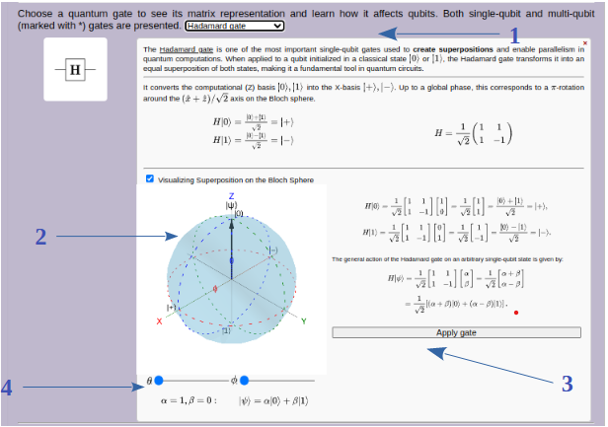

The Single-Qubit State Evolution tool can be used to visualize how the state of a qubit changes when one or more quantum gates are applied. This interactive representation helps illustrate the geometric interpretation of quantum state evolution and the effect of quantum gates on the Bloch sphere.

Using the Single-Qubit State Evolution tool, perform the following exercises:
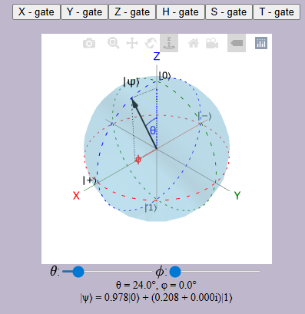 | - Set the initial state to ∣0⟩. Apply a Hadamard gate and record the final state in Dirac notation. Describe the corresponding movement of the state vector on the Bloch sphere.  - Starting from ∣0⟩, apply the Pauli-X gate. Compare the initial and final states.  - Starting from ∣+⟩, apply the Pauli-Z gate. Determine the final state and explain the observed transformation.  - Apply the Hadamard gate twice to the state ∣0⟩. What is the final state? Verify the result using both the Bloch sphere and the matrix representation of the gate.
- Starting from the state |0⟩, apply a Hadamard gate followed by a Pauli-X gate. Write the final state in Dirac notation.
- Starting from the state |0⟩, compare the results obtained by applying the gates in the order Hadamard then Pauli-X and Pauli-X then Hadamard. Are the final states identical? What conclusion can you draw about the order of quantum gate operations?
- Choose an arbitrary initial state using the Bloch sphere controls. Apply a sequence of at least three quantum gates and record the state after each operation.
- Find a sequence of one or more quantum gates that transforms the state |0⟩ into the state |1⟩. Verify your result using the Bloch sphere visualization.

4. In the last section, “Quantum Cryptography: Applications“ of the module (https://qtechedu.centralesupelec.fr/EN/ex10.html) is to demonstrate how the principles of quantum computing can be applied to encryption and information protection.
We propose the Quantum Gate Challenge as an illustrative and pedagogical example.
The goal of this challenge is to find the secret key used to encrypt a phrase. The key consists of a sequence of quantum gates forming a quantum circuit that serves as the encryption mechanism. By applying the key (the chosen encryption quantum circuit) in reverse order, the original phrase can be recovered.

